***Equity Intelligence System***

EagleEYe the New Generation Trading Decision System

Feature Description

|  |
| --- |
|  |

Preface

About this document

Now India is one of emerge economy in the world hence the investors different corners from the globe interested put their money in Indian equity market. Earlier time big of chunk of money are into different class like property, bank fixed deposit as there are awareness via different medium hence Indians are interested in putting their money to MUTUAL FUND .Now of Indian hardly 15 percent into the mutual fund so huge potential to grow Indian equity market.

Table of Contents

1. Executive Summary 1

2. Architecture OF EagleEYe 2

2.1. Overview 2

3. Challenges 3

4. Acronyms 4

# Executive Summary

Today world inflation is increasing 8 percentage per annum as per data provided by the government. With earning whatever you have done always in short fall basically middle class group have to compromise life in somewhere .So to generate guaranteed revenue from the equity market the product named EagleEYe took birth it starts from 8 month before still in crawling stage. The major objective of the product tap the middle class group with minimum of amount of investment and at the end give some return which more than bank saving from equity or stock market .This new trading software is intended for trading as well analyse the data for short and long term investment in Indian equity market.

# Architecture OF EagleEYe

## Overview

The eagle eye monitor the data form the stock exchange NSE in real time manner with time frame of 8 minute interval.

***OverView Of EagleEYe architecture.***

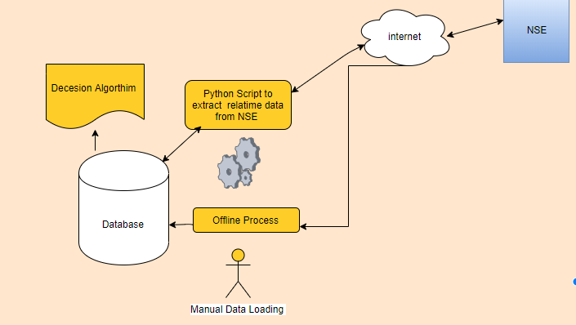

Note: Currently 55 large cap stocks tracked by EagleEYe.

Currently we are using the database as oracle and in future free ware database can be replace like mySql Cassandra DB etc.

Technology used for EagleEYe

* Oracle 12C XE version
* Python 3.2

# Challenges

Currently the data base is used as oracle hence it cannot be hosted in cloud plat form hence POC need to be done on successful POC completion need to migrate entire application in free ware database which can be hosted on cloud platform.

Automated the manual data loading process using latest technology.

# Acronyms

NSE –National Stock Exchange.

Equity Market- Share Market